NN Challenge UiPath

Framework
The framework chosen is an enhanced modification from the original UiPath, which I'm currently using in a professional environment.
Since the process prompts the user, I've decided to use as an Attended Robot, which works as a Dispatcher and a Performer at the same time.
It currently uses a Queue so we enable retry policies for every user we would like to retrieve Linkedin info.
As a configuration file, I use Storage Bucket, in which the CSV file is stored and then retrieved throught an Orchestrator Asset.
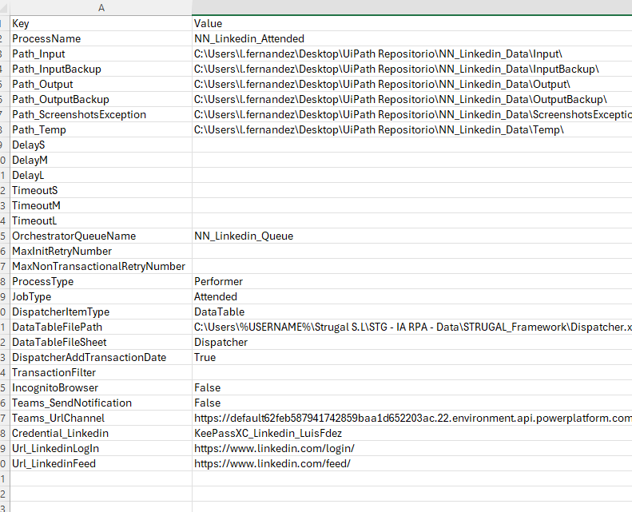
As credential store, I use KeePassXC as a key vault.
Init State
After loading the Config, here we prompt the user in case it’s the first time the process is running, afterwards, we upload to the process queue. Then we close any application related to this process and do the Log in Linkedin.
GetNextTransaction
As Attended, this part gets a QueueItem from the process queue.
Process
We process here the QueueItem, considering that when we finish with this item, we set the web application in a proper state so we can process the next QueueItem.
End
Finish the applications used by the process.

Current Process Components
-Framework folder has all the relevant components needed to run a new process.
-Modules folder has reusable components used by the process that can be used later on another new process.
Linkedin_LogIn: Used to log in Linkedin.
Linkedin_GetToolsAndTechnology: Used to navigate and gather "Tools & Technologies" section.
-Process folder refers to those components that are unique to the process.
AppendExcel: Used to whether we need to create or update the report excel file.
GetUserInfo: Prompts the user to get the people needed to process.

